Assessment Schedule – 2014
Mathematics and Statistics: Apply calculus methods in solving problems (91262)
Evidence Statement
ONE |  | Achievement (u) | Merit (r) | Excellence (t)
 |  | Apply calculus methods in solving problems. | Apply calculus methods, using relational thinking, in solving problems. | Apply calculus methods, using extended abstract thinking, in solving problems.
(a) | g'(x) = 3x² – 4  g'(2) = 8 | Derivative found AND gradient found.
(b) | f(x) = x³ +2x² – x – 9 | Anti-derivative AND function found. f(x) not required. C = –9 accepted.
(c) | d'(t) = 2.5t – 4  2.5t – 4 = 0  t = 1.6  d(1.6) = –3.2 | Derivative found AND equated to 0 OR t = 1.6. | Time for minimum AND depth found. Accept 3.2 with evidence of substitution of 1.6 into d'(t).  Units not required.
(d) | f '(x) = –2x + k  –2x + k = 0  k = 2x  Since x = 3, k = 6  f(x) = –x² + 6x – 5  f '(x) = –2x + 6  f '(4) = –2 | Derivative found  AND k = 6 found. | Gradient found.
(e) | g'(x) = 2x² + 3x –20  2x² + 3x –20 = 0  (2x – 5)(x + 4) = 0  x = 2.5, –4  Check gradient:  g'(0) = –20 < 0 ⇒  decreasing.  OR shape of graph  + ve cubic OR g'’(x) test.  –4 < x < 2.5 | Derivative found  AND = 0 or < 0. | Derivative found and the  x values of turning point found (g'(x) = 0 may be implied) | Region correctly identified AND justified using one of the methods. Can be in words.
(f) | v(t) = 0.5625t² – 4.5t + 21  a(t) = 1.125t – 4.5  1.125t – 4.5 = 0  t = 4  s(4) = 60.5 km | Velocity equation  found. | Acceleration equation found AND set equal to 0 (s''(x) = 0 may be implied). | Distance found. Units not required.

NØ | N1 | N2 | A3 | A4 | M5 | M6 | E7 | E8
No response; no relevant evidence. | Attempt at one question | 1 of u | 2 of u | 3 of u | 1 of r | 2 of r | 1 of t | 2 of t

TWO |  | Achievement (u) | Merit (r) | Excellence (t)
(a) | 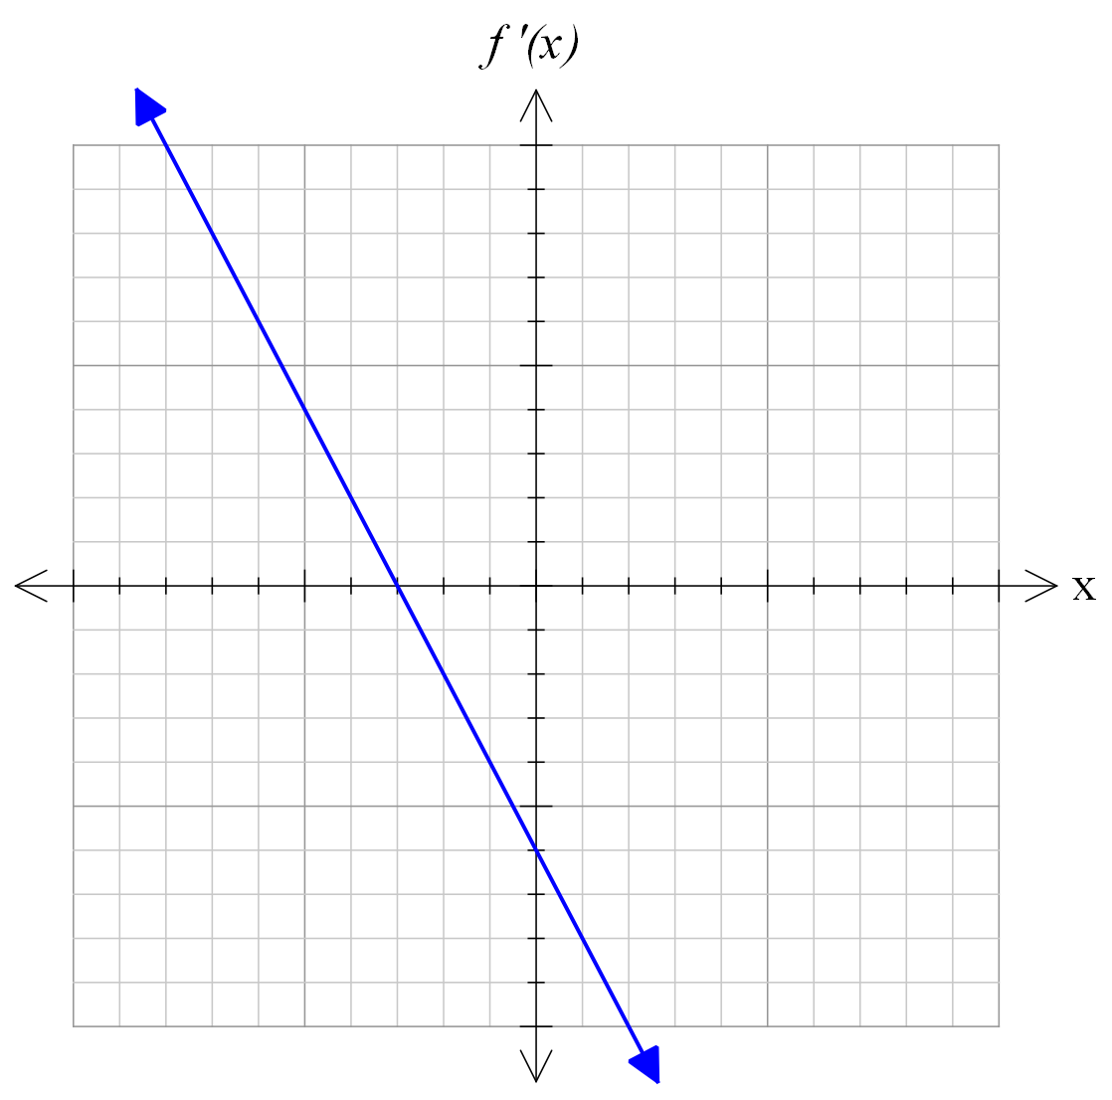 | Straight line with negative gradient AND  x-intercept –3.
(b) | g(x) = x² – 5x + c  c = 0  g(3) = –6 | Anti-derivative AND  y-coordinate found.
(c) | R'(t) = 300t – 2250  300t – 2250 = –150  t = 7 years | Derivative found  AND set to –150. | t found. TE for $150 gives t = 8. Accept one MEI with evidence. Set to -150 can be implied.
(d) | 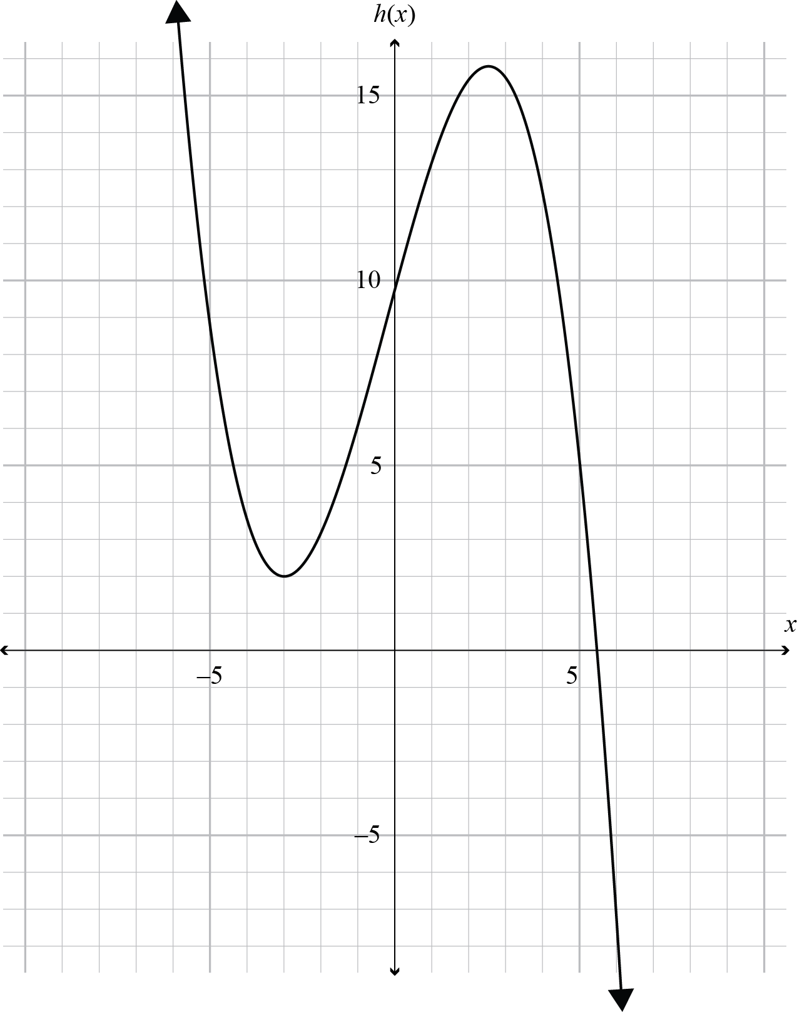 | Negative cubic with minimum at (-3, 2) OR  negative cubic with TP’s at x = -3 and 2 < x < 3. | Negative cubic with  minimum at (–3,2) AND the second TP indicated in the range 2 < x < 3.
(e) | 9x – 3x² = 0  3x(3 – x) = 0  x = 0, 3  Max at x = 3  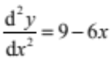  When x = 3,  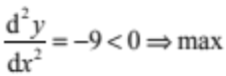  OR shape of graph  –ve cubic OR Check gradient:  y'(2) = 6 > 0  y'(4) = –12 < 0 ⇒ MAX  Hence passes through (3,–4)  y = 4.5x² – x³ + c  -4 = 4.5x² – x³ + c  c = –17.5  y = 4.5x² – x³ – 17.5 | x values of turning points identified.  OR  Correct integration set equal to –4. | Maximum turning point at  x = 3 identified, justified and the point (3,–4) used using one of the three methods. | Equation of curve found in y= form.
(f) | 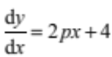  When x = 3, y = 9p + 7 and  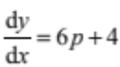  y – (9p + 7) = (6p + 4)(x – 3)  Subst. (0,4),  p = –1  Equation of tangent is  y + 2 = –2(x + 3)  OR gradient of tangent  at x = 3 is –2.  When x = 3, y = –2  Equation of tangent is  y + 2 = –2(x – 3)  OR  y = –2x + 4 | Expression for the gradient found when  x = 3. | Value of p found. | Equation of tangent found.

NØ | N1 | N2 | A3 | A4 | M5 | M6 | E7 | E8
No response; no relevant evidence. | Attempt at one question | 1 of u | 2 of u | 3 of u | 1 of r | 2 of r | 1 of t | 2 of t

THREE |  | Achievement (u) | Merit (r) | Excellence (t)
(a) | f ' (x) = 4 – 2x  4 – 2x = 10  x = –3 | Gradient function AND solution found.
(b) | V(h) = 20h² + 40h  V'(h) = 40h + 40  V'(0.75) = 70 | Derivative found AND rate of change found.  Units not required.
(c) | 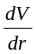= 4πr²  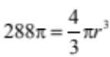 Plus 1 line  For given volume r = 6  Rate of change  = 144π or 452.4. | Derivative found AND attempt to find r using correct equation – one correct rearrangement required. | Rate of change found. Units not required.
(d) | V'(x) = 900x – 36x² = 0  900x – 36x² = 0  x(900 – 36x) = 0  x = 25 cm  Since h + x + 3x = 150  then h = 50 cm | Derivative found, set  to 0, AND x found. V'(x) = 0 can be implied. | h found. Units not required.
(e) | g'(x) = (x – 2)² – 1  = x² – 4x + 3  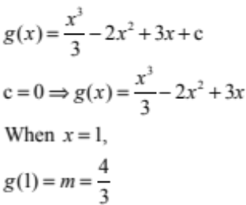 |  | g(x) found – particular solution with evidence  c = 0. | m found. Ignore rounding.
(f) | v(t) = –3.3t + c  t = 0, v = 70  ⇒ v(t) = –3.3t + 70  s(t) = –1.65t² + 70t + c  t = 0, s = 0  ⇒ s(t) = –1.65t² + 70t  4 = –3.3t + 70  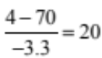  t = 20  s(20) = 740 metres | Velocity function found. | Distance function found. | Distance found. Units not required.

NØ | N1 | N2 | A3 | A4 | M5 | M6 | E7 | E8
No response; no relevant evidence. | Attempt at one question | 1 of u | 2 of u | 3 of u | 1 of r | 2 of r | 1 of t | 2 of t

Cut Scores
 | Not Achieved | Achievement | Achievement with Merit | Achievement with Excellence
Score range | 0 – 7 | 8 – 14 | 15 – 20 | 21 – 24

